Azure Monitor: Independent service

1. We can see end to end monitor infrastructure completely. In the on premises, it is known as SCOM (System center operating manager). Cloud version of SCOM is Azure monitoring services
2. It collects two types of monitor data. Logs and Metrics. How to monitor different types of resources webapps, containers, VMs, NIC we monitor like single point of administration
3. It has two components. Log analytics workspace plays the keys role in azure monitor because what ever data is injected can be stored in log analytics workspace and we the same in Azure monitor
4. Splunk is most used tool which do the functionality of Azure monitor tool however Splunk is an innovative tool in which there is a search engine capability. All the coming VMS resources and data will be stored in Splunk database
5. At 8:30 VM will be down we don’t know the reason behind it in Splunk we can fetch the logs before 8:30 PM and we can analyses that
6. Similar kind of functionality we can see in log analytics workspace we have queries in which it is stored in database and logs are uploaded. For running the queries we will use language KQUL. (KQL, the Kusto Query Language)

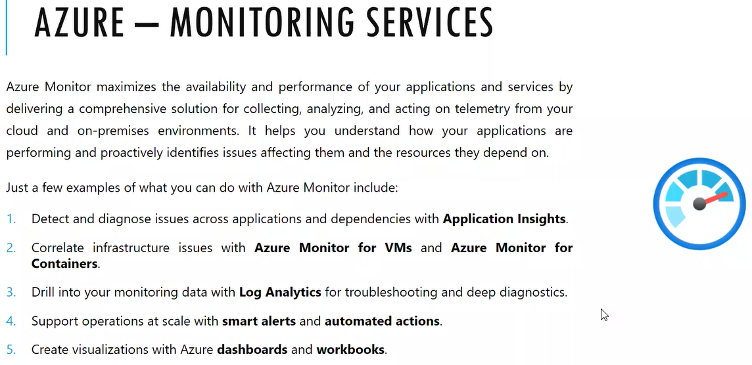7. We can use in the azure monitor in the on premises by installing the agent called monitoring service agent

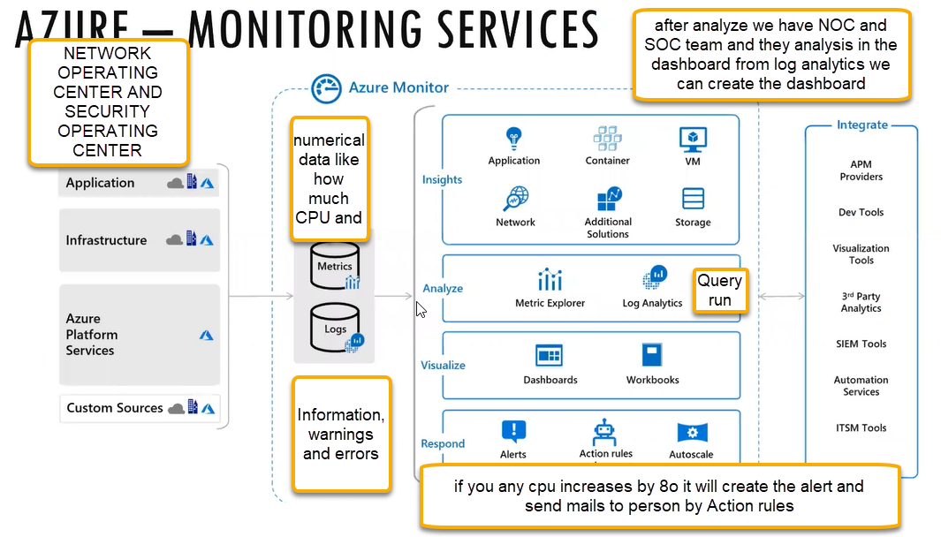

1. If you on board the security system center services, VMS Immediately Microsoft azure agent will be installed
2. In Azure we have deep analysis function those are insights if there is a web application then we have insights and VM machine we have VM insights
3. We can monitor the VM in the hypervisor point of view it will have consolidated physical server monitor solution we can do or if you install monitor solution inside VM then we can monitor from that end also

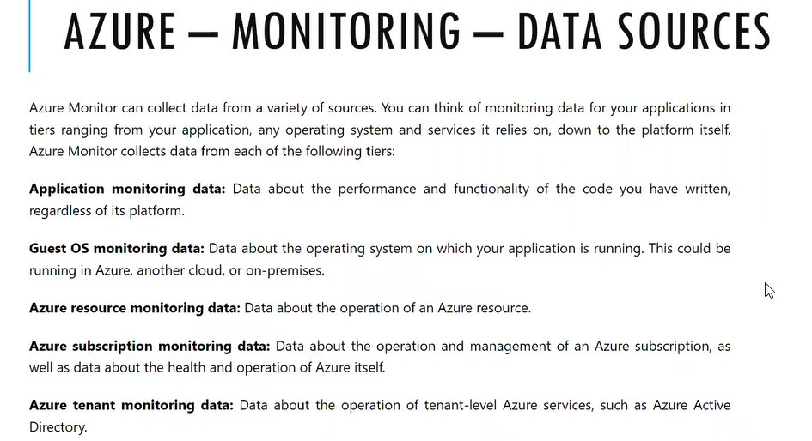

1. From the data we got we can fits into metrics and logs

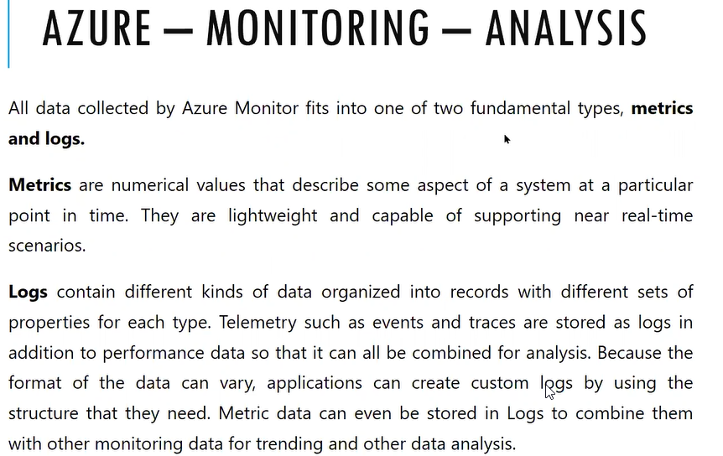

1. In the monitor page > overview > we can see what’s new post. We can see enable the insights from VM level or consolidated Azure monitor level
2. We don’t need to enable the Azure monitor it is default enabled when just to enable in resource level
3. We need to collect the data resource from Insights tab
4. Insights > Application We need to deploy the web application (Platform as service) so that we analysis the data

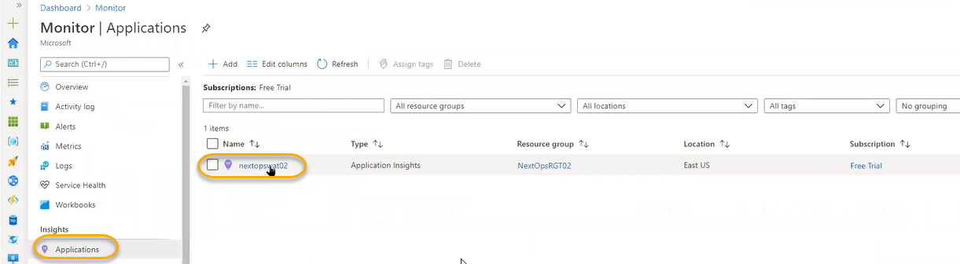

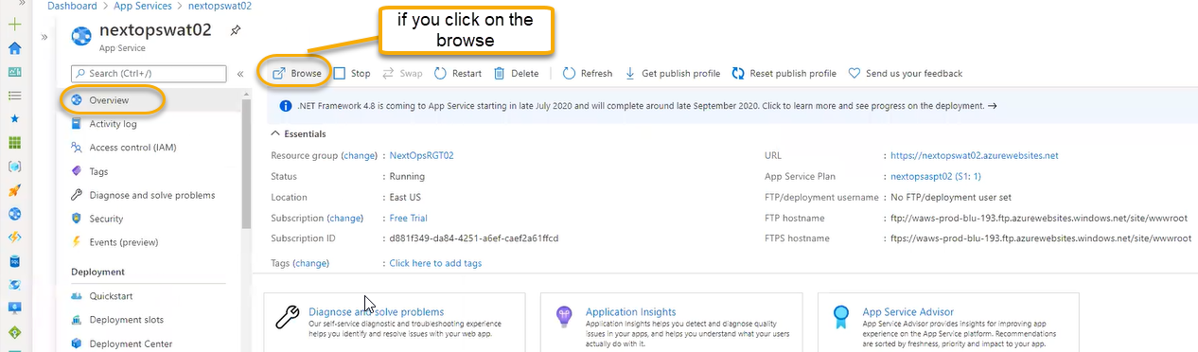

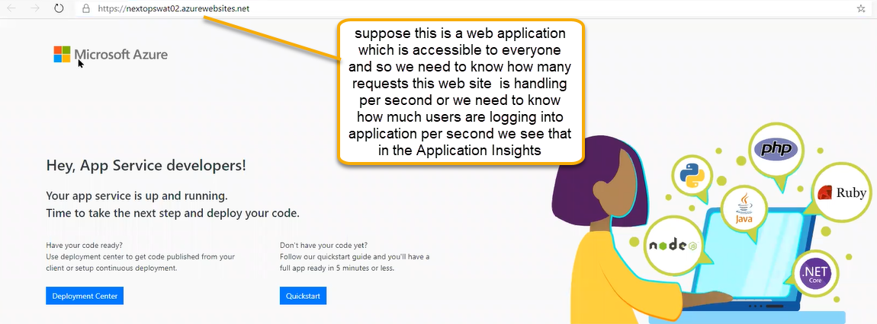

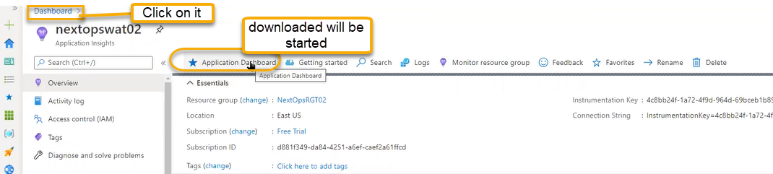

Web application related complete monitor we can see in the dashboard and we can see that in the full screen

Azure home page we can see dashboard when we login

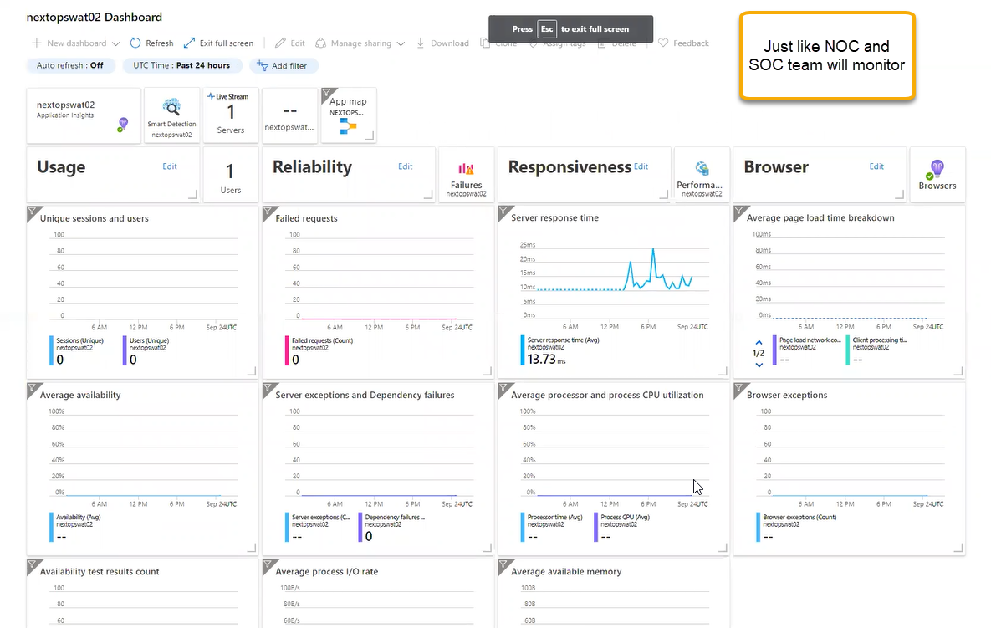

Application map if our web application is mapped to database then we can see the data

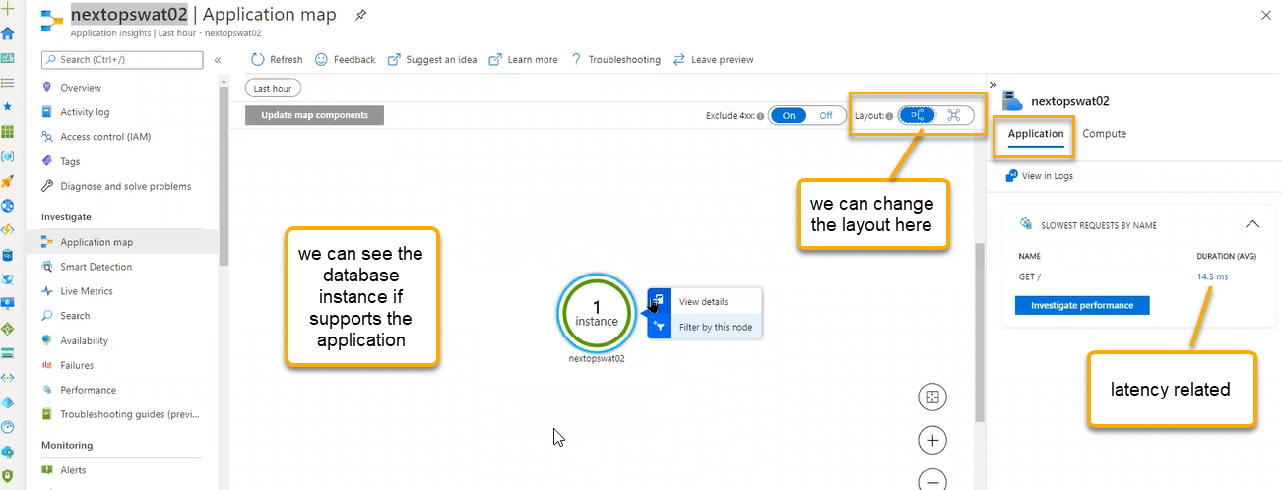

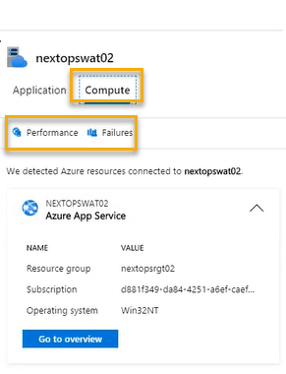

Smart Detection: we can see the critical alerts and we can see the CPU usage and, we can filter out using Time range (Time period) and we can see all the information through dashboard

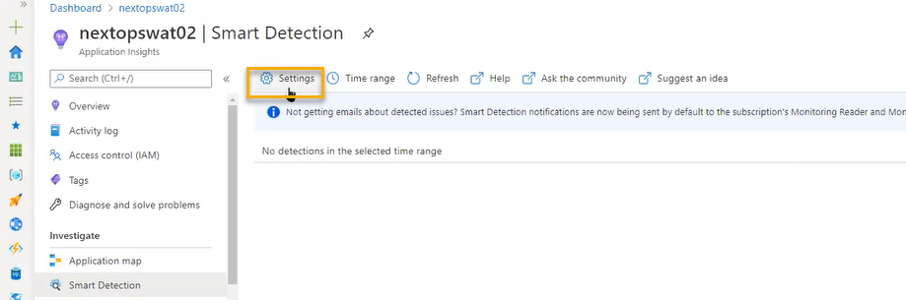

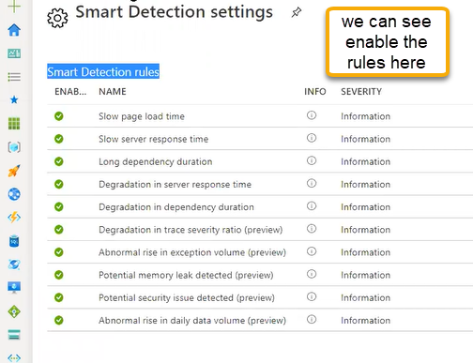

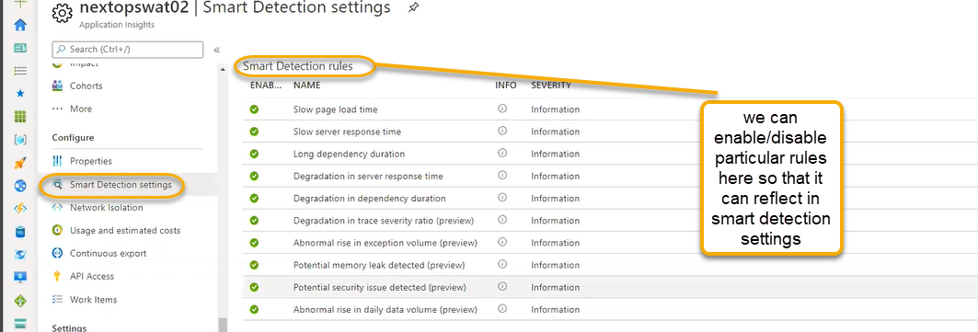

Live Metrics: we can see the live data if you enable the application insights in the web application in the backend sdk will be enabled in the platform

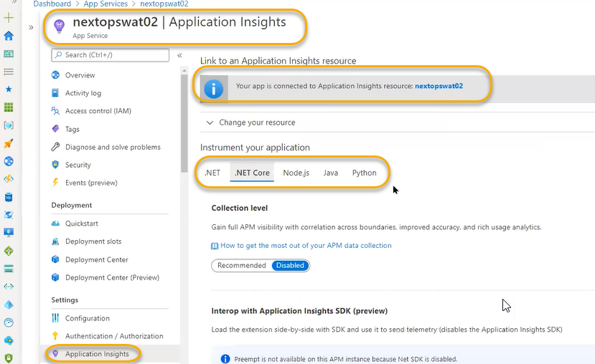

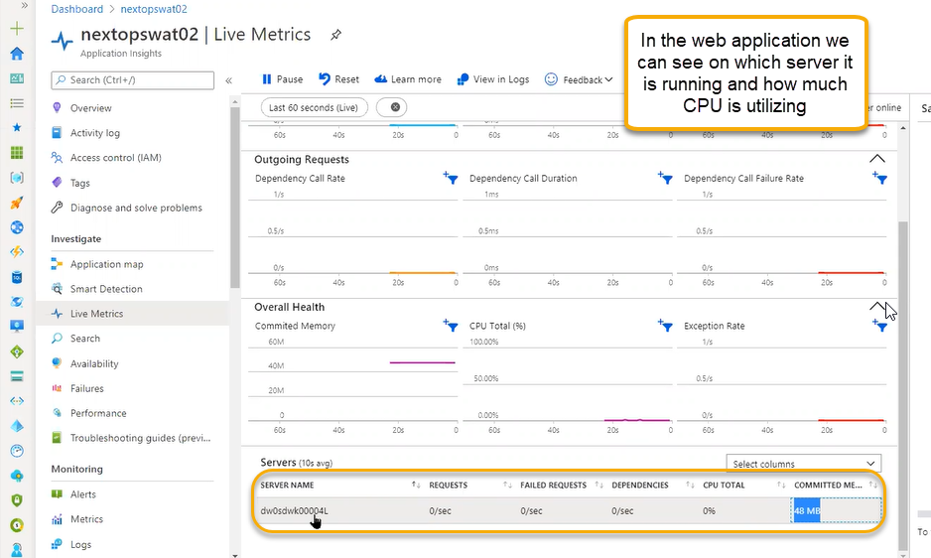

Since it has PAAS, we don’t have any control on servers and if you click on the server then we can see that filter has been added

Search: once the data is collected periodic and if you want to use the monitoring in infrastructure or monitoring historic data is important or a month of data is important to conclude the exact the issue.

Capacity planning: in the current point of time infrastructure is running ( Example: if any company is running and for the year ending the sales is high so that we need more infrastructure and after that infrastructure size is normal so we need to forecast the next infrastructure by the end of the end of the year by monitoring the data

Server, CPU and network utilization data we can see for year ending and we can forecast accordingly, and we can add additional resources

Availability: how much available the application is and we can test it

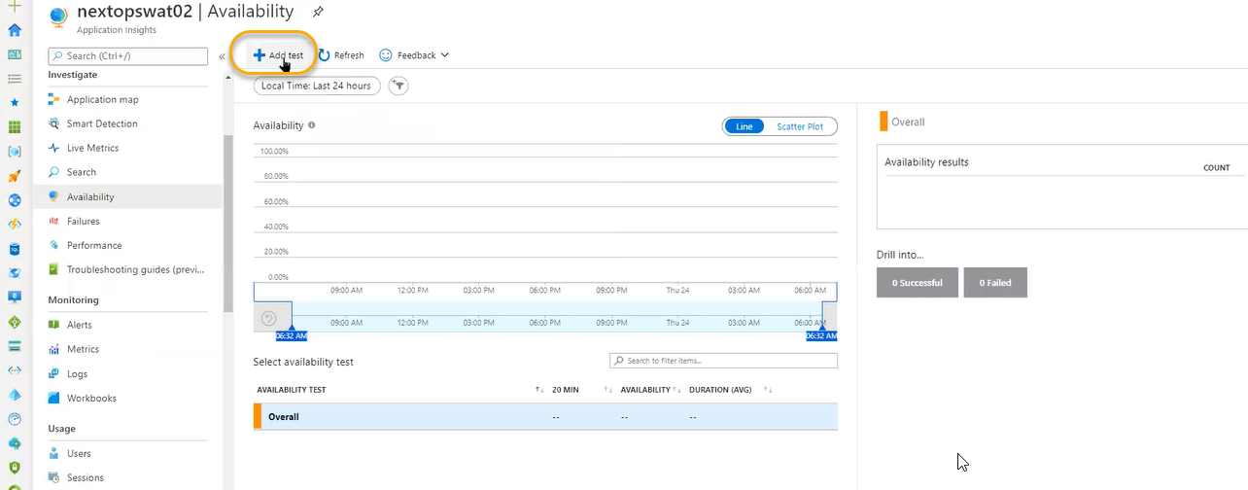

For every 5 minutes it will ping if the application is Up and running

In the test locations we can see on which locations that url has to ping based on customers utilization

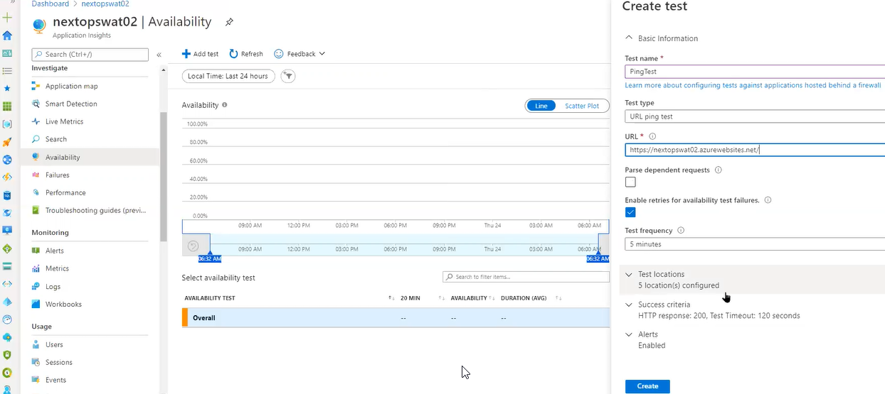

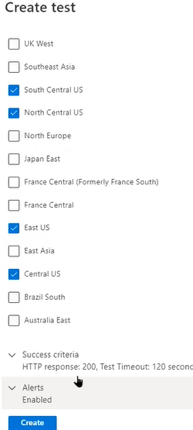

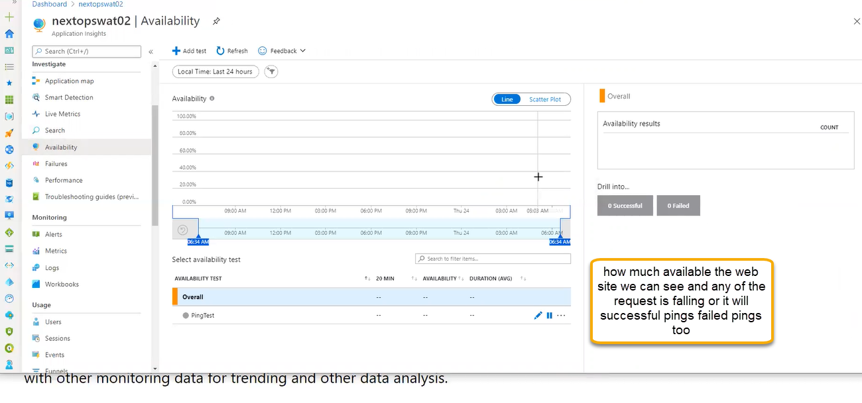

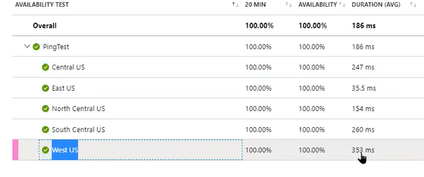

Highest latency we can see in the west US and least we can see in the East US

Failures: Based on the availability option enabled we can the data in failures tab

If end user is accessing the website and any request is failing or if you see any exceptions (when logging any particular tab in the page we may get error)

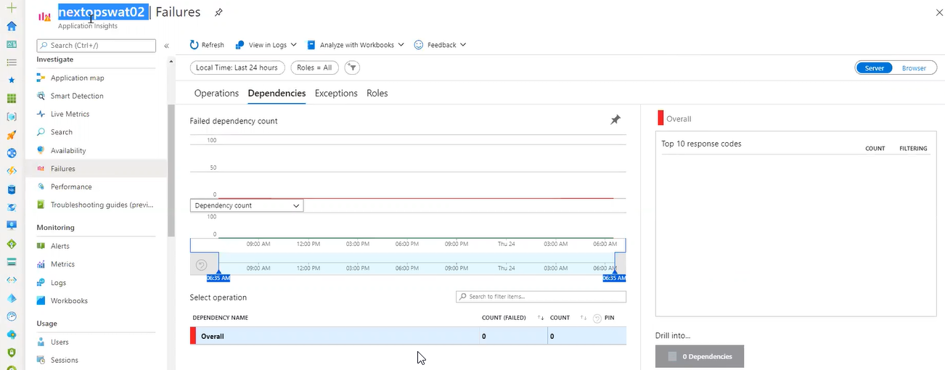

Performance

Get is to retrieve the data in that particular time how many requests are coming

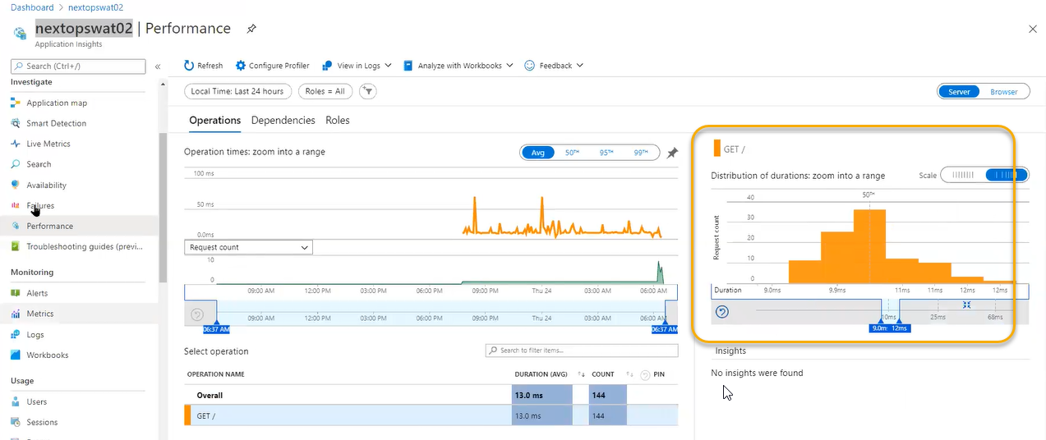

Troubleshooting guides : It just like workbook guides

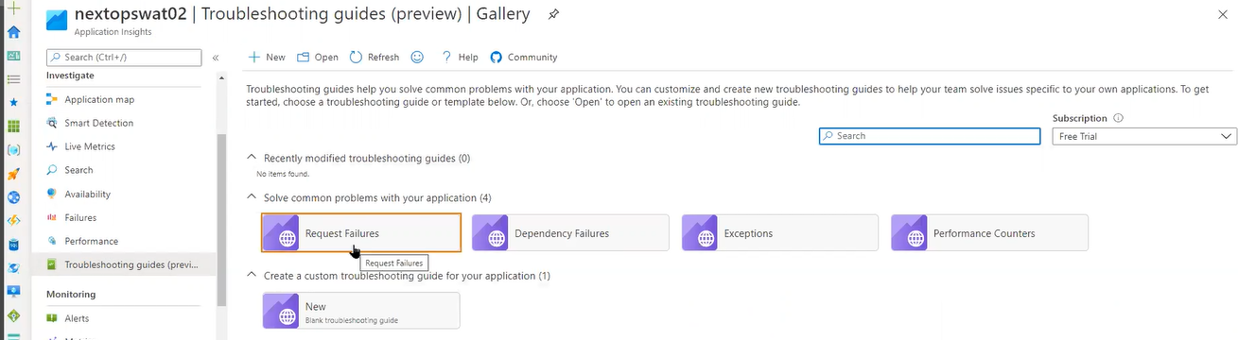

If any one of the issues will occur, we can visualize the things

Live metrics: the data will be captured in the live and whereas in the metrics we can see the data as a historic

Usage: these are the analytics. This is used for end user point of view and related to business

If you want to monitor continuously our website. Google service is running continuously on google analytics and it will show how many requests is handling particular to our website

Similar kind of information we can see the usage monitoring

User flow: can show from which page to which page user is navigating

Sessions how many times the user is logging the application

Network Isolation : we can integrate the web apps in different ways one is Vnet for creating the web service we need App service plan it will give CPU plan and storage

Usage and estimated costs : cost is based on per GB

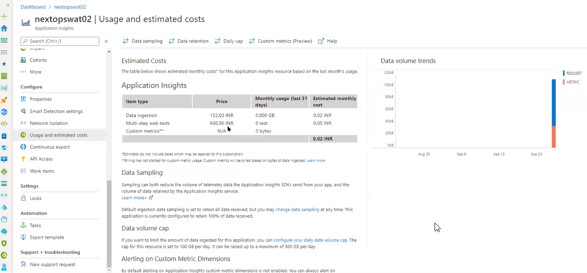

Continuous export instead of storing the data in log analytics we can store In the storage accounts

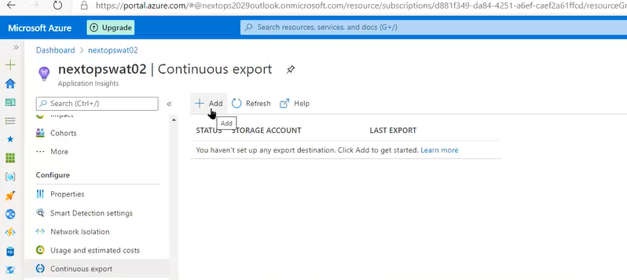

API Access: if we have third party analytics and we need to access from third party from Azure then we can do from here

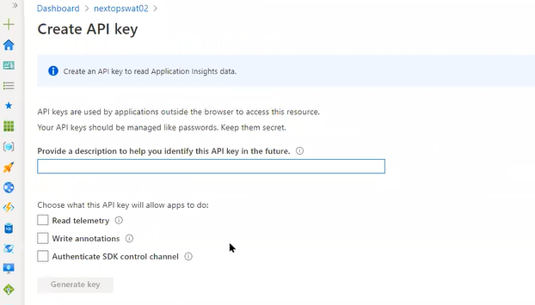

Work Items

Related to Azure devops if any alert is generating then immediately a ticket will be raised and that ticket will assign to concerned person

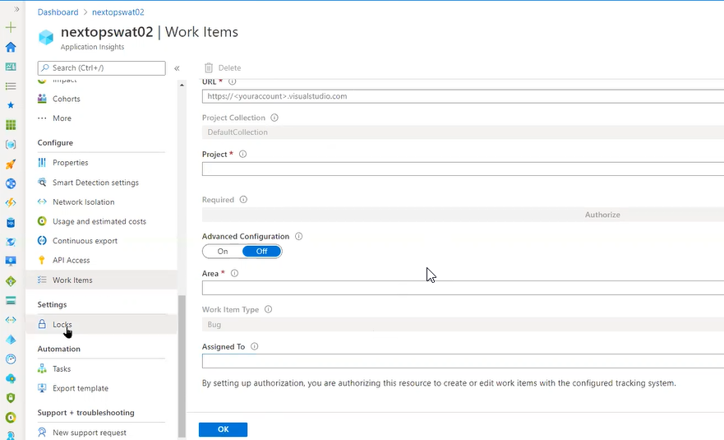

Task

If you want an email notification related to monthly usage then we can configure here

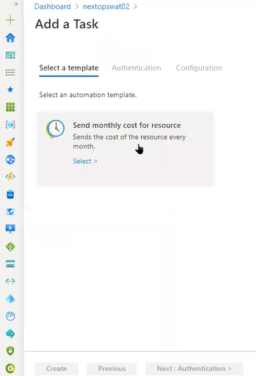

Insights > Virtual Machines

We can see only azure VM and NOT the on premises VM. However, we can see that in the Insights Hub > Log Analytics workspace

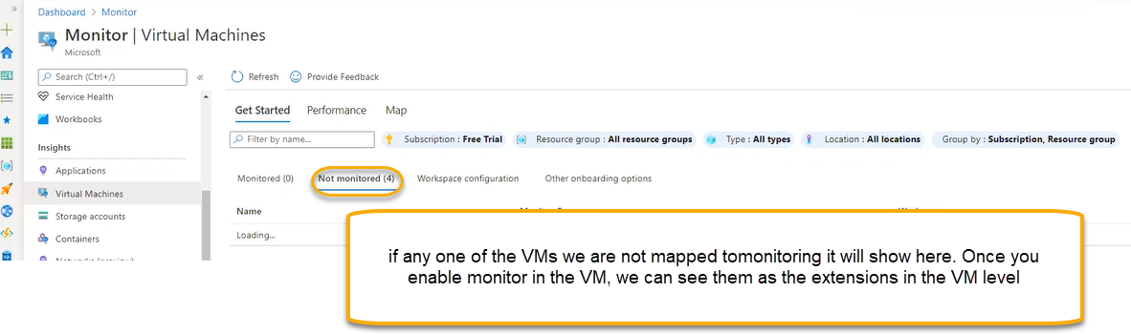

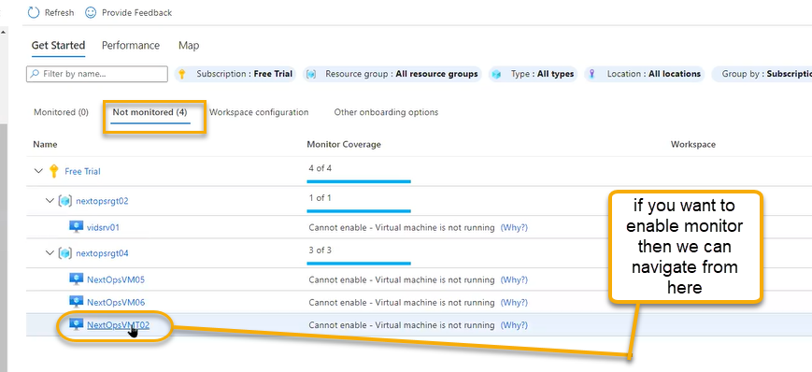

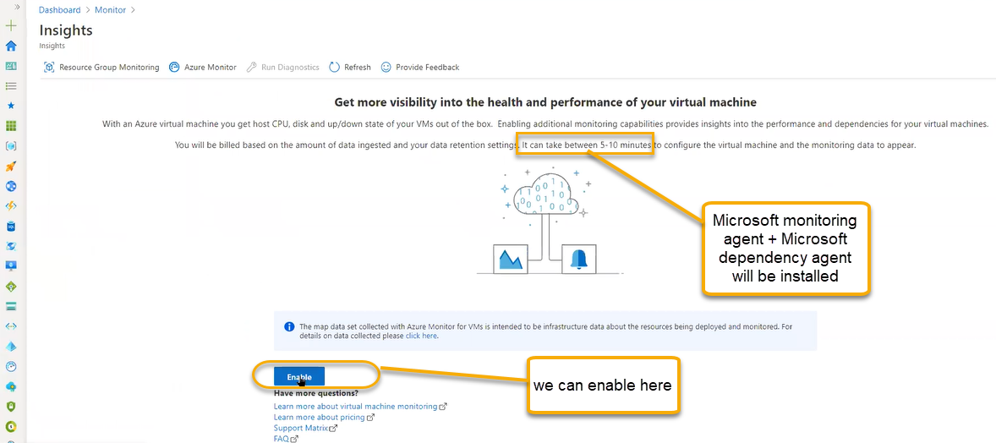

Once installed/enabled that VM is moved to Monitored section. MMA ( Performance related data) and MDA ( in the installed VM services any web apps are running then we can see that in map level) if we need the map then Microsoft dependency agent will be installed

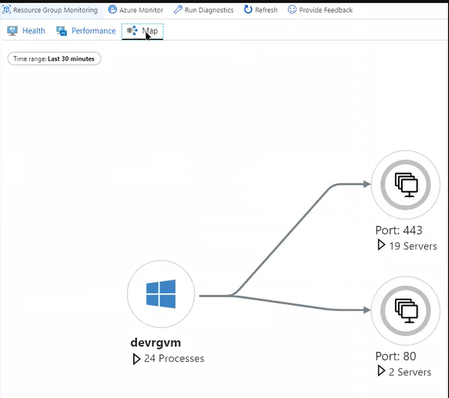

For on premises machine we will connect to log analytics workspace

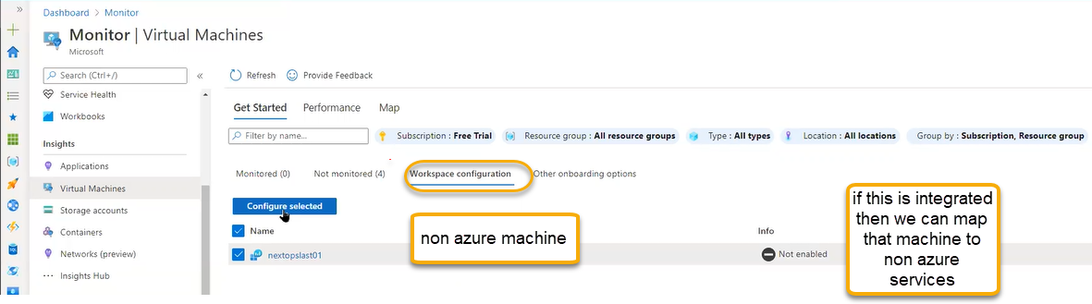

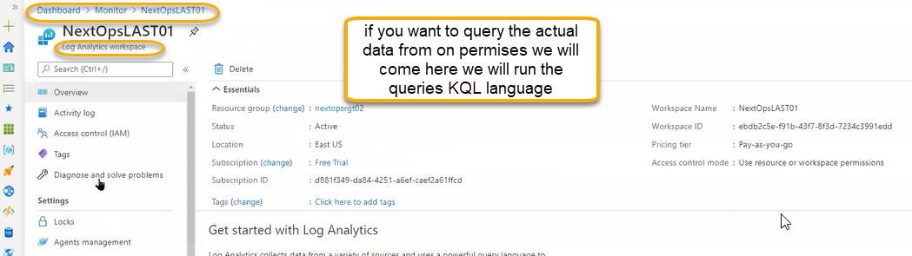

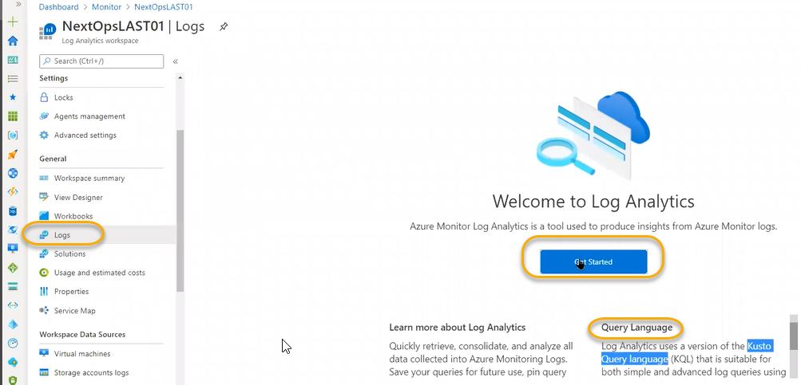

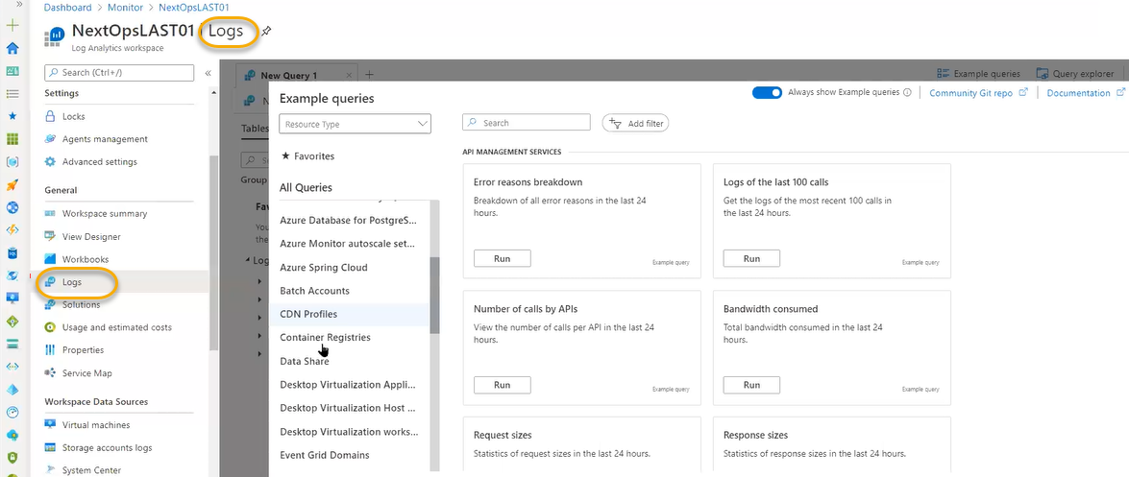

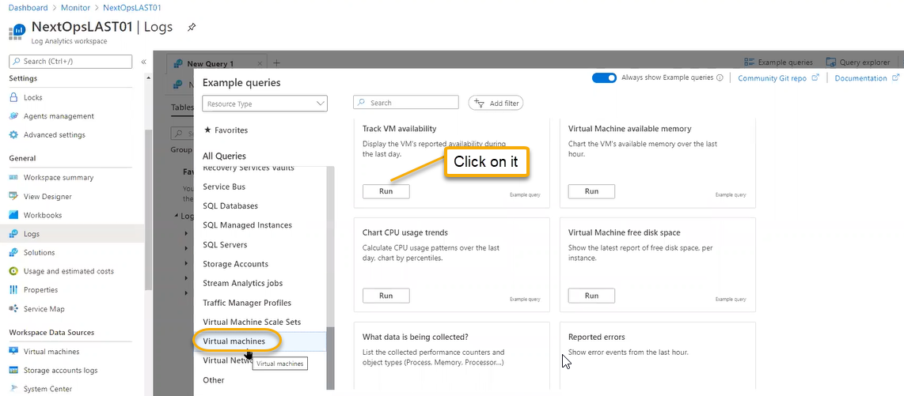

If you click on the Run then Load to editor will open we can edit the KQL language and use it / Run it